A Retinal Radiance Meter
Mou Tongsheng¹, Yu Jiandong², Li Li¹
¹Optical Engineering Department of Zhejiang University, Hangzhou, China
²Zhejiang University Sensing Instruments Co., Ltd, Hangzhou, China

abstract
Optical radiation safety, e.g. LED safety, is being given more and more attention. Several regulations are made for different characteristics of optical radiation in IEC 60825 series standards and IEC 62471/CIE S: 009 standards. However, traditional luminance or radiance meter, which is not based on the photobiological measurement, often can not be used to implement Optical Safety Testing. Consequently, based on IEC 62471, a novel retinal radiance meter, based on the retinal photobiology of the human eye, is described in this paper, which is capable of measuring optical radiation hazard parameters, e.g. angular subtense, effective spectral radiance.
Keywords: LEDs safety, optical radiation hazard, radiance meter

Introduction
The hazard to human eyes from UV-VIS-NIR optical radiation is being given more and more attention. Especially because high power, bright GaN based white LEDs and RGB mixture LEDs are widely used in signage industry, lighting, displaying, etc, the potential retinal hazard is more obvious. Several regulations are made for different characteristics of optical radiation in IEC 60825 series standards and IEC 62471/CIE S: 009 standards. In the hazard level evaluation of the eye retina, the more important case is to measure effective exposure on the retina from the apparent source, which is determined by the angular subtense of the apparent source (α), the effective spectral radiance, and the pulsed characteristics of the light source.
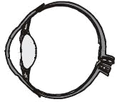
Figure 1. The angular subtense of the apparent source (α)
α
α
The angular subtense (α) is the visual angle subtended by the apparent source at the eye or at the point of measurement, should be determined (Figure 1). However, due to physical limitations of the eye, the visual angle subtended by the retinal spot is neither below α_{min} nor above α_{max} [1][2], thus for apparent sources subtending an angle below α_{min} or above α_{max}, the exposure limits for retinal hazards are independent of the source size.
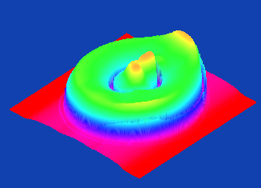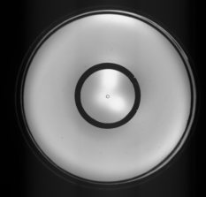
Figure 2. Radiance distribution of a LED lamp
Because of eye movements, the radiance on the viewing field should be measured for a specified measuring field angle according to exposure duration. The effective spectral radiance (L_{λ}) shall be averaged over a right circular cone field-of-view (α_{eff}). Besides, generally the radiance distribution of LED lamp is not uniform (Figure 2), the maximum weighted radiance (L_{B}, L_{R}, L_{IR}) shall be determined.
1
0.5
T≤0.25s
Figure 3. Pulsed waveform
Because some light sources, e.g. pulsed lamps, radiate in the form of a single pulse or a train of pulses (Figure 3) [1][2]. The weighted exposure for each pulse should be determined by integration of the weighted exposure from the light source over the full pulse width after verifying that the integration time is limited to a maximum of 0,25 s. Therefore, both the spectral radiance and the pulsed waveform should be measured.

WHAT’S PROBLEMS
In IEC 62471, for lamps intended for general lighting service, the blue light weighted radiance and the burn hazard weighted radiance at a distance which produces an illuminance of 500 lux, but not at a distance less than 200 mm need to be measured. During the measurement of the weighted radiance, for light sources that don’t produce spatially uniform irradiance, such as LEDs, the input aperture diameter should be held at 7mm diameter.
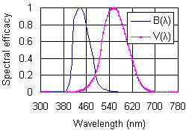
Figure 4. The spectral response V(λ) of photopic vision of a luminance meter, and the spectral weighting functions B(λ) for assessing retinal blue light hazard.

In order to determine the blue light weighted radiance (L_{B}) and the burn hazard weighted radiance (L_{R}, L_{IR}), the radiance meter should has the same spectral response as B(λ) and R(λ). A traditional luminance meter often can not be used to implement the above measurement. First, the spectral response of photopic vision is not fit for the evaluation of optical radiation hazard (Figure 4). Second, in order to keep the solid acceptance angle of the detector constant, the input aperture diameter of a traditional luminance meter would be changed while the light source is focused at different measurement distance. However, in optical hazard assessment, the diameter of reception aperture of the instrument shall be kept constant. Third, the aperture diameter of a traditional luminance is often bigger than 7mm. As shown in figure 5, in case of a traditional luminance meter, suppose that its aperture diameter is D, and a white reference is used to calibrate it, the measurement of the source is at 200mm distance, the beam spread profile of the white reference and the tested LEDs are shown in figure 6. The test result is given by:
(1)
Where:
L_{LED} is the luminance of the tested LED, L_{S} is the luminance of the white reference.
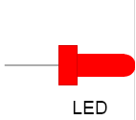
White reference
Standard lamp
Figure 5. traditional luminance measurement procedure, (a) Calibration, (b) Testing.
(a)
(b)
Φ₁
Ω
Ω
Φ₂
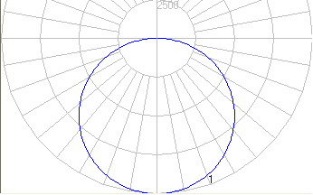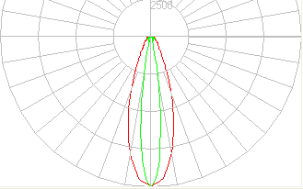
Figure 6. Beam spread profile of Lambertian Surface (left) and LED (right).

34°
14.6°
In figure 6, two LEDs with beam angle 14.6°and 34°are shown. Compare with a luminance meter whose input aperture diameter is 7mm, we can calculate the change of luminance of both LEDs tested by luminance meters whose input aperture diameter is bigger than 7mm:
(2)
Where:
L_{D} is the luminance/radiance of the tested LED tested for input aperture diameter D, L_{7mm} is the luminance/radiance of the tested LED tested for diameter 7 mm of input aperture.
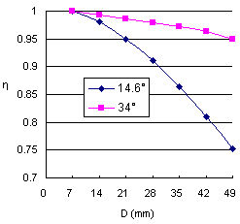
Figure 7. Variation of test results with the diameter D of input aperture
As shown in figure 7, the bigger aperture diameter is, the smaller the tested luminance, which is more obvious for the tested LED with narrow beam angle. Consequently, a traditional luminance meter will often underestimate the optical radiation hazard of symmetry LEDs with narrow beam.

A RETINAL RADIANCE METER
We have developed a retinal radiance meter, which is capable of measuring the angular subtence of the apparent source (α), the effective spectral radiance, and the pulsed characteristics of light sources, can be used for the assessment of the effective exposure on the retina.
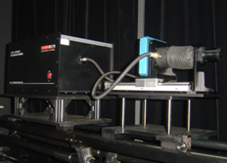
Spectroradiometer
Digital imaging meter
Figure 8. A retinal radiance meter
Digital imging meter
Imaging lens
Beam diverger

Fiber
Spectroradiometer
F
F
The input aperture with 7mm diameter is located on the front focal plane of the imaging lens to simulate the human eye (figure 9). A photoreceptor with specific field stops is positioned on the imaging plane of the apparent source to detect the incident radiation. For imaging light source at any distance, the angle of acceptance is constant. By use of a small integrating sphere combined with a spectroradiometer, the spectral irradiance on the receiving port in the wavelength range from 380nm to 1400nm could be measured. According to the blue-light hazard function B(λ) and the burn hazard weighting function R(λ), both the blue light weighted radiance and the burn hazard weighted radiance could be measured. Besides, similar to human eyes’ image searching, the 2-D CCD digital imaging meter could be applied to get the area and orientation of maximum radiation of tested light source, and determine the dimension of the apparent source. The flash spectroradiometer with 1MHz sampling frequency can be applied to measure the spectral distribution of the light source, and the spectral pulse waveform at each wavelength.
Figure 9. The imaging setup with a constant acceptance angle
f
Aperture
Lens
Image
Object

MEASUREMENT

Angular subtense
The determination of α, the angle subtended by the apparent source of a source, requires the determination of the apparent source area of the source. In IEC 62471, the apparent source area of a source is composed of emission points whose radiance is above 50% of the peak value of the source [1][3]. In this paper, the 2-D CCD digital imaging meter is used to determine the apparent source, and figure 10 shows the test result. Since the input aperture with 7mm diameter is located on the front focal plane of the imaging lens, the angular subtence of the apparent source (α) can be given by:
(3)
Where: D_{a} is the diameter of the image of the apparent source, f is the focal length of the imaging lens.
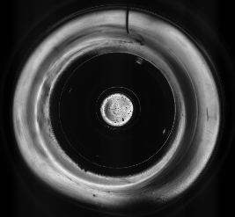
Figure 10. Radiance distribution (left) and the apparent source area (right).
Besides, the Location of the apparent source and the measurement angle play an important role in LED safety measurement. Figure 11 shows the image of the CCD accommodated to image the cap, some distance behind the cap and the chip of a white LED. Figure 12 shows the area change of the apparent source of a same LED at different viewing angle.
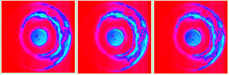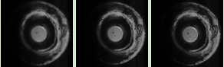
Figure 11. The image of the CCD accommodated to image (a) the cap, (b) some distance behind the cap, (c) the chip.
(a)
(b)
(c)
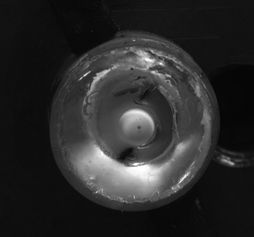
Figure 12. The apparent source of a white LED at different viewing angle.

Pulsed characteristics
The pulsed characteristics measurement of the pulsed light source requires the determination of the pulsed waveform and the spectral radiance. Common methods, e.g., using a photocell with an oscilloscope, should be applied only on condition that the spectral uniformity of the pulsed light source over the full pulse width is sufficient. A flash spectroradiometer with 1MHz sampling frequency, using two photodetectors (Figure 14), could not only measure the spectral distribution of the light source, but also the spectral pulsed waveform at each wavelength.
Photodetector 1
Figure 13. Basic diagram of the flash spectroradiometer
Photodetector 2
As shown in Figure 13, provide that Φ(t, λ) is radiance determined by Photodetector 2, t is the testing time, φ(λ, t) is spectral radiance determined by Photodetector 1, and Φ(t, λ) and φ(λ, t) are determined synchronously. The temperal sprectal distribution at t₀ can be given by :
φ’(λ, t₀)= K×φ(λ, t₀)/Φ(t₀, λ) (4)

Spectral weighted radiance
The weighted radiances are given by:
(5)
(6)
(7)
Where:
L_{λ}(λ) is the spectral radiance of the tested LED, B(λ) is the blue-light spectral weighting function, R(λ) is the retinal thermal weighting function.
Figure 14. Basic diagram of the retinal radiance meter.
CCD

Overlapped area
In figure 14, the measurement areas of the spectroradiometer and the CCD digital imaging meter are overlapped, thus the test result from the overlapped area on CCD can be corrected by the test result from the spectroradiometer. Using the spectroradiometer to measure the relative spectral radiance (L’_{λ}(λ)) of the tested LED, and correct the test results of the 2-D CCD digital imaging meter to determine weighted radiances.
Provided that S(λ) is the spectral response of the CCD, the test result of the CCD is given by:
(8)
And:
(9)
Then:
(10)
(11)
Consequently, the spectral radiance of the tested LED can be determined.

TEST RESULTS
A typical LED module was tested, figure 15 and table 1 show the test results.
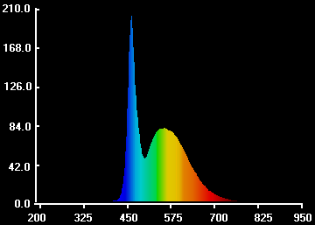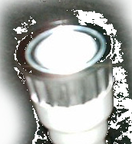
Figure 15. Spectral distribution of the tested LED
Table 1. Tested results
Retinal radiance meter
Weighted radiance | Field of view  (mrad) | Result  (W/m²/sr) | Distance  (mm)
L_{B} | 1.7 | 415.43 | 200
L_{B} | 11 | 393.12 | 200
L_{B} | 100 | 144.28 | 200
L_{R} | 1.7 | 6099.25 | 200
L_{R} | 11 | 4898.91 | 200
L_{IR} | 11 | 0 | 200
L_{IR} | 34.8 | 0 | 200

CONCLUSIONS
Therefore, the retinal radiance meter could be conveniently used to measure the dimension and the location of the apparent source at different conditions, the pulsed spectrum characteristics of pulsed light sources, the blue light weighted radiances and the burn hazard weighted radiances over specific field of views, etc, in order to make optical radiation safety assessment of LEDs and other broadband light sources.

references
[1] IEC 62471: Photobiological safety of lamps and lamp systems
[2] IEC 60825-1 Safety of laser products – Part 1: Equipment classification, requirements and user’s guide, Edition 1.2, IEC Geneva (2001)
[3] Mou Tongsheng, The apparent sources determination for LEDs, CIE 2007

Acknowledgements
Authors: Optical Engineering Department of Zhejiang University, Hangzhou, China
Name: Mou Tongsheng
Affiliation: Yu Jiandong
Address: Zhejiang University Sensing Instruments Co., Ltd, Hangzhou, China
Affiliation: Li Li
Address: Optical Engineering Department of Zhejiang University, Hangzhou, China
Phone: 86-571-85021543
Fax: 86-571-87977635
e-mail: sensingm@163.com

